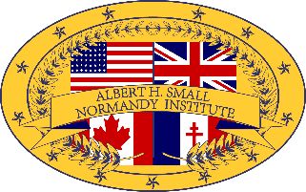
The Albert H. Small
Normandy Institute

Parental Consent Form

By submitting this form, I confirm that I…

- have read and understand the information about the Albert H. Small Normandy Institute at www.ahsnormandyinstitute.com and have given my son/daughter permission to apply. I agree to release, indemnify, and hold harmless the Albert H. Small Normandy Institute, its staff, agents, and employees from liability of bodily harm or property damage that might occur during the program. If my child has a medical condition that requires health services and/or medication during this trip, I have communicated those needs to the teacher who will be accompanying my child and to the staff of the Institute. In the event of an emergency, reasonable attempts will be made to contact me. This will not prevent an emergency health care provider from acting in the best interests of my child. I authorize emergency medical treatment for my child in the event of an accident or illness during the Institute. I agree that the Institute may use photos or videos taken during the Institute that include my child's image in materials published in any manner by or about the Institute.

___________________(Name) ___________________(Date)

